# MIS 275 - Lab 4

Once you have completed the assignment then upload it to Blackboard. Save your document with the following naming convention:

* Course_Lab Number_First Initial Last Name (Example: MIS275_Lab4_LStewart.docx)

Complete Chapter 3 Problems 10 and 15 Pg. 111 (Cengage)

For problem 10, provide your answer here.

Table: EMPLOYEE 🡪 primary key: EMP_CODE foreign key: JOB_CODE

Table: BENEFIT 🡪 primary key: EMP_CODE foreign key: PLAN_CODE

Table: JOB 🡪 primary key: JOB_CODE foreign key: NONE

Table: PLAN 🡪 primary key: PLAN_CODE foreign key: NONE

For problem 15, paste a screen print of your ERD here

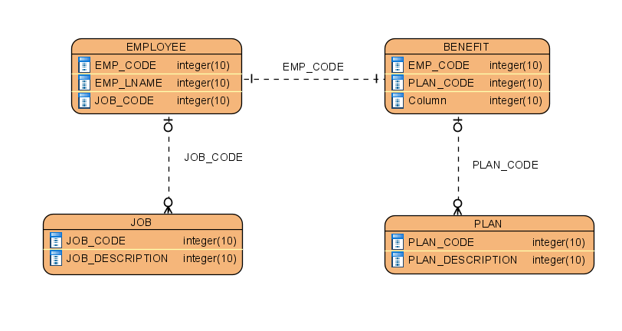

Complete Chapter 4 Problem 4 Pg. 157 (Cengage)

Paste a screen print of your ERD here.

